AccessibilityOz

Web Accessibility Evaluation Tool
Web Developer Toolbar
Coding

By: AccessibilityOz
Date: November 2013

Contents

Web Accessibility Evaluation Tool Web Developer Toolbar Coding 1
Contents 2
Evaluating coding 3
Steps to take 3
Coding testing with the WDT 3
Checklists 7
Automated checking 7
Manual checking (with the tool) 7
Manual review of the site 7
Resources 10
Web Developer Extension 10
Further information 10
AccessibilityOz 10

Evaluating coding

Steps to take
- Ensure you have downloaded and installed the Web Developer Toolbar (http://chrispederick.com/work/web-developer/) before continuing.
- Open the FireFox or Chrome web browser and go to a webpage.
Coding testing with the WDT
The WDT does not have specific tests for all the checklist requirements; some require manual review with and without the tool.

Automated testing
- Using the ‘Information’ selection menu, select ‘Display Tab Index’.
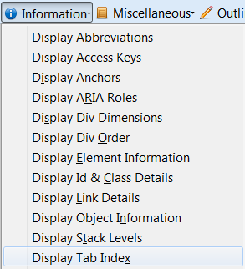

Example: TABINDEX attribute and value will display if present.
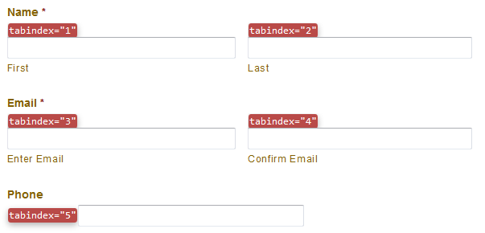
Any occurrence of TABINDEX fails COD_A11
- Using the ‘Information’ selection menu, select ‘Display Access Keys’.
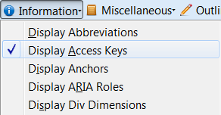
Example: ACCESSKEY attribute and value will display if present.
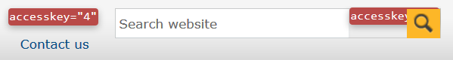
Any occurrence of ACCESSKEY fails COD_A12

Manual checking (with the tool)
- Using the ‘Outline’ selection menu, select ‘Outline Frames’.
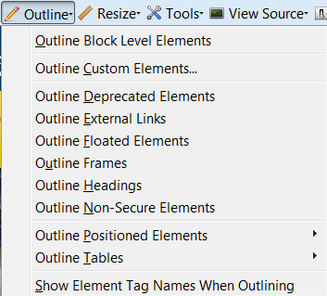
Example: Frames outlined on the page

- Use the ‘View Source’ selection menu, select ‘View Frame Source’.
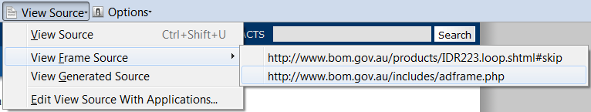
- Manually review all IFRAME code/s to check for a text alternative within the start and end <IFRAME> element.
All iFrames must pass COD_A3
- Using the ‘Tools’ selection menu, select ‘Validate HTML’.
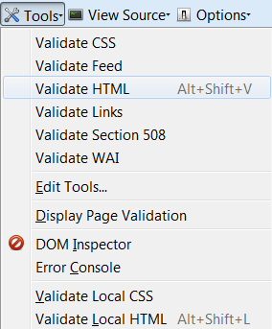
- The W3C Markup Validation Service will load in a separate tab/window.
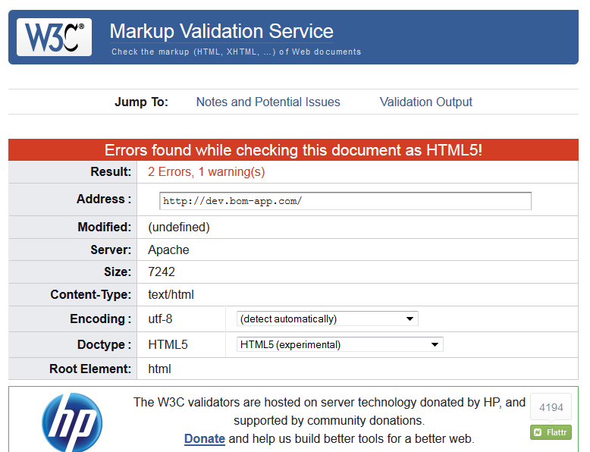

Example: Validation errors found
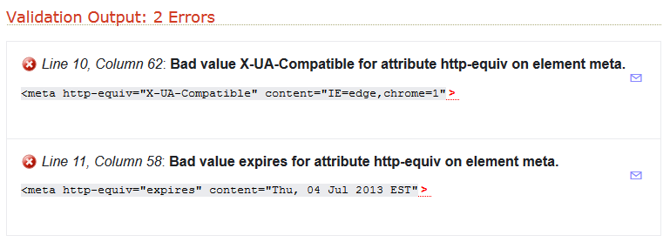
- Any errors found will be listed and require manual review for confirmation.
All pages must pass COD_A16i, ii, iii, iv, v, iv

Checklists

Automated checking
Ref | Requirement | Yes | No
COD_A11 | TABINDEX has not been used?
COD_A12 | ACCESSKEY has not been used?

Manual checking (with the tool)
Ref | Requirement | Yes | No
COD_A3 | Does the IFRAME element have an accessible alternative?
COD_A16i | Is the HTML valid (i.e. tags are closed properly)?
COD_A16ii | Is the HTML valid (i.e. XHTML tags are self-closing)?
COD_A16iii | Is the HTML valid (i.e. tags are closed in the order they are opened)?
COD_A16iv | Is the HTML valid (i.e. block level elements are not nested inside inline elements)?
COD_A16v | Is the HTML valid (i.e. compulsory tags are not omitted)?
COD_A16vi | Is the HTML valid (i.e. character entities are coded correctly)?

Manual review of the site
Ref | Requirement | Yes | No
COD_A1 | Do emoticons, ASCII art or leetspeak have an accessible alternative?
COD_A2 | Does the EMBED element have a text alternative?
COD_A4 | Has MathML been used for equations (i.e. not images)?
COD_A5 | Have short quotations been marked up with the Q element?
COD_A6 | Have blocks or sections of text quoted from other sources been marked up with the BLOCKQUOTE element?
COD_A7 | Have lists have been coded properly with UL, OL and LI elements?
COD_A8 | Do all pages specify a DOCTYPE?
COD_A9 | Is the DOCTYPE correct?
COD_A10 | Deprecated features (elements and/or attributes) have not been used?
COD_A13 | LONGDESC has not been used?
COD_A14 | ONKEYPRESS has not been used?
COD_A15 | The APPLET element has not been used to embed objects?
COD_A17 | Has the FIELDSET element been used correctly?
COD_A18 | Has the LABEL element been used correctly?
COD_A19 | Has text been indented with style sheets (i.e. not using the BLOCKQUOTE element)?
COD_A20 | Do elements contain mandatory attributes?
COD_A21 | Have variations in the presentation of text been indicated in the content of the page?
COD_A22 | Is all moving or scrolling content keyboard accessible?
COD_A23 | Has English or Australian English been coded as the default language?
COD_A24 | Is the LANG attribute incorrect on foreign language pages?
COD_A25 | Inactive text has not been coded to visibly appear like links (i.e. not underlined)?
COD_A26 | Are email links active?
COD_A27 | Are website links active?
COD_A28 | Have links been used to reference supporting information (i.e. not asterisks and/or superscripts)?
COD_A29 | Do HREF elements contain content (i.e. not empty)?
COD_A30 | JavaScript ONCLICK links have not been used?
COD_A31 | JavaScript ONKEYPRESS links have not been used?
COD_A32 | A timed redirect has not been used?
COD_A33 | The BLINK element has not been used?
COD_A34 | The MARQUEE element has not been used?
COD_A35 | The general or red flash threshold has not been violated?
COD_A36 | Can all moving or scrolling content be stopped?
COD_A37 | Do animated GIFs stop within 5 seconds?
COD_A38 | Do all session time outs have a warning?
COD_AA1 | Images of text have not been used instead of text (except logos)?
COD_AA2 | Is the font type consistent?
COD_AA3 | Are all links working (i.e. no broken links)?
COD_AA4 | Can the text be resized to 200% without loss of content or functionality?

Resources

Web Developer Extension
Web Developer Toolbar (download)
http://chrispederick.com/work/web-developer/
Web Developer Extension for Mozilla-based Browsers (by WebAIM)
http://webaim.org/resources/webdev/
Web Developer Blog
http://blog.chrispederick.com/
Web Developer Forum
http://forums.chrispederick.com/

Further information

AccessibilityOz
Web: www.accessibilityoz.com.au
Phone: 03 8677 0828
Email: enquiries@accessibilityoz.com.au
Address: Level 9, 440 Collins Street, Melbourne 3000

