AccessibilityOz

Web Accessibility Evaluation Tool:
OzART
Coding

By: AccessibilityOz
Date: November 2013

Contents
Web Accessibility Evaluation Tool: OzART Coding 1
Contents 2
Evaluating coding 3
Steps to take 3
Testing with OzART 5
Evaluating coding 5
Checklists 11
Automated checking 11
Manual checking (with the tool) 12
Manual review of the site 13
Resources 14
OzART 14
Further information 14
AccessibilityOz 14

Evaluating coding

Steps to take
- Select a report to view from the Coding category suite of reports:
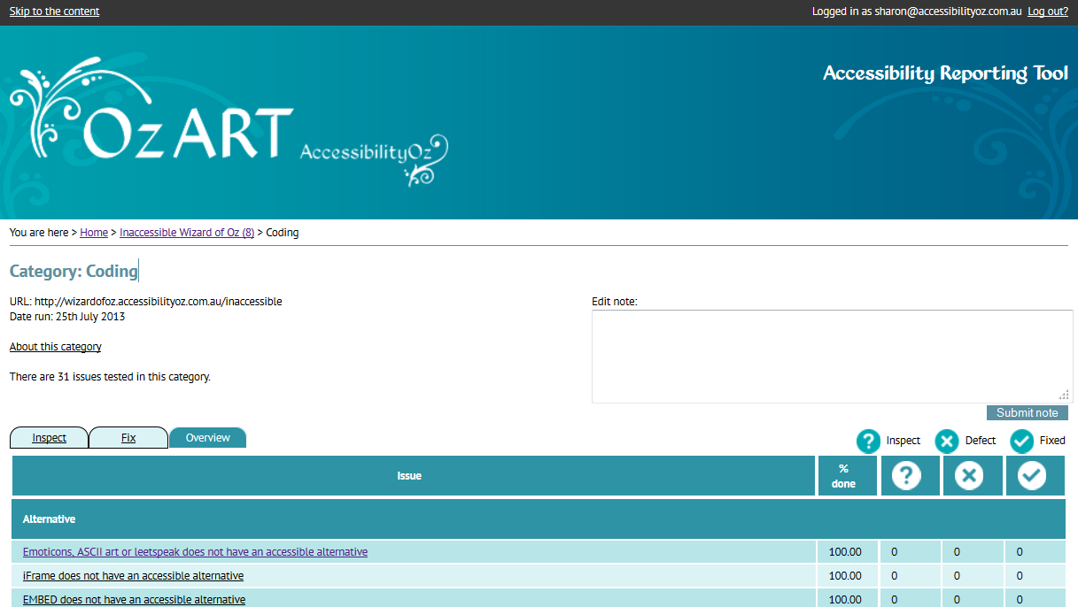
- Follow the checklists to identify any accessibility errors.
OzART is used to generate automatic lists of failures but can also be used to guide and inform the testing where specific reports are not provided leading to the creation of error specific lists of URLs for each error type which can then help with the implementation of a correction.

OzART coding reports
Each Coding report contains the following information:
- Information about the report and a link to the relevant pages on the OzWiki;
- the WCAG 2.0 level and impact of the error under test with the report;
- the status e.g. Inspect, Defect, Fixed;
- the number of entries in the report;
- report specific information needed to determine whether the item passes or fails to comply with the requirement; and
- the referencing page i.e. the URL.
An example of an OzART coding report display is as follows:
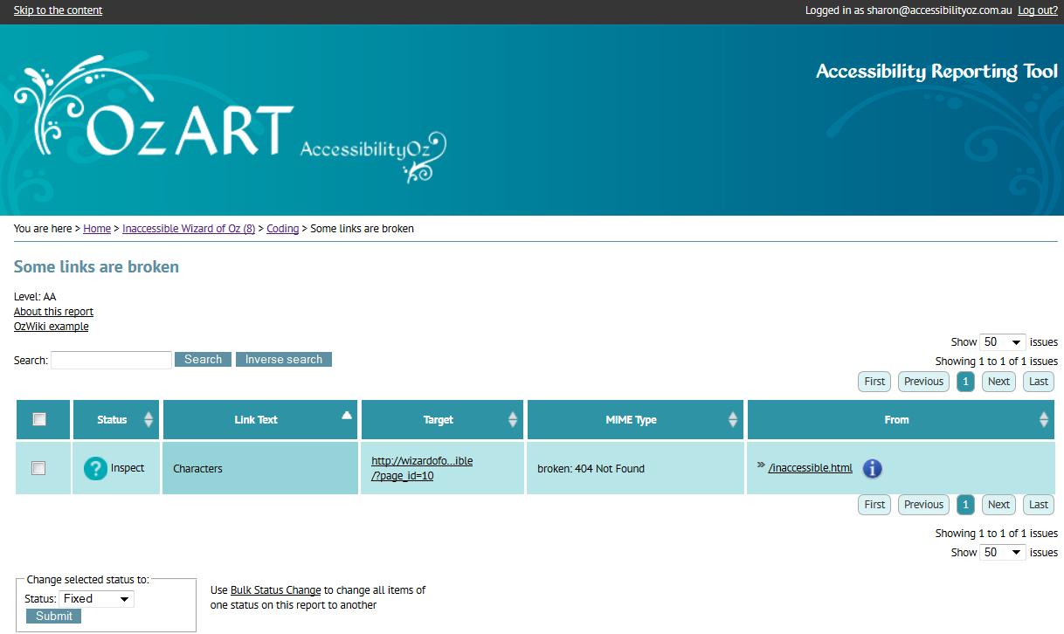

Testing with OzART

Evaluating coding
OzART has specific tests for most of the checklist requirements; some require manual review with and without the tool.

Automated checking
Pages do not specify a DOCTYPE
Any page in this report fails COD_A8
DOCTYPE specified is incorrect
Any page in this report fails COD_A9
Deprecated features (elements and/or attributes) have been used
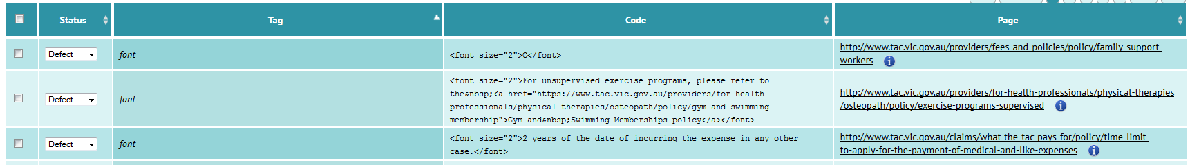
Any page in this report fails COD_A10
TABINDEX has been used
Any page in this report fails COD_A11
ACCESSKEY has been used
Any page in this report fails COD_A12
LONGDESC has been used throughout the site
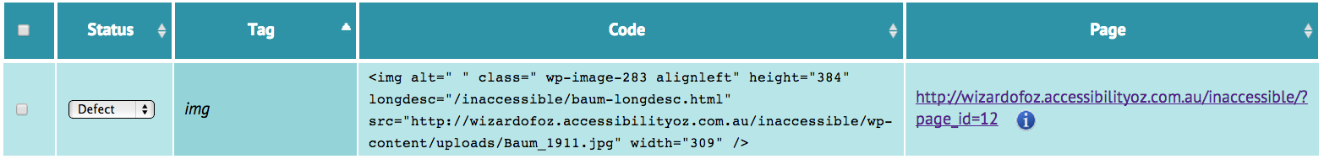
Any page in this report fails COD_A13
ONKEYPRESS has been used
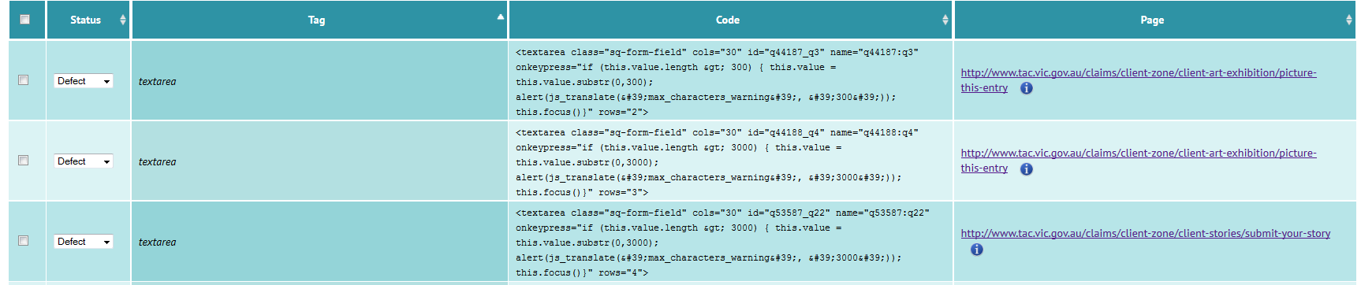
Any page in this report fails COD_A14
APPLET has been used to embed objects
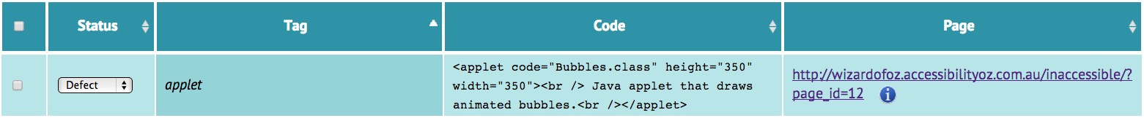
Any page in this report fails COD_A15
HTML is invalid
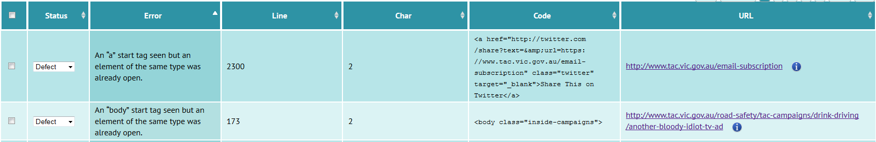
Any page in this report fails COD_A16i, ii, iii, iv, v, vi
Mandatory attributes are missing from some elements
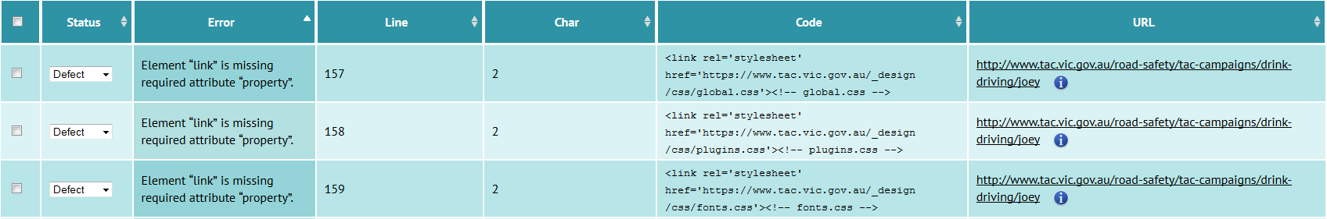
Any page in this report fails COD_A20
English has not been coded as the default language
Any page in this report fails COD_A23
Inactive text has been coded to visibly appear like links
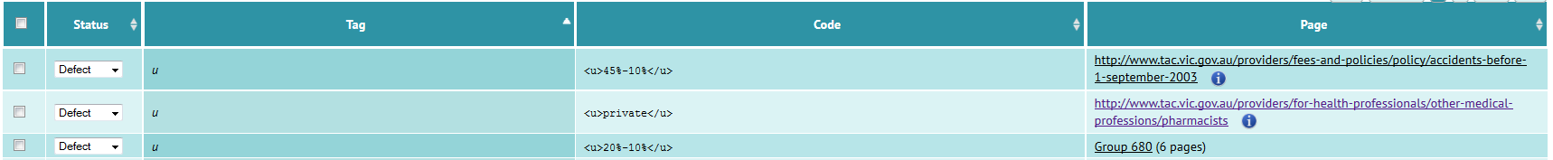
Any page in this report fails COD_A25
Some link text is not active (email words)
Any page in this report fails COD_A26
Some link text is not active (www words)
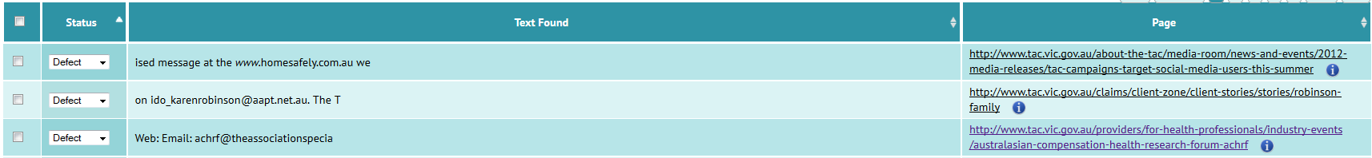
Any page in this report fails COD_A27
The site contains empty links
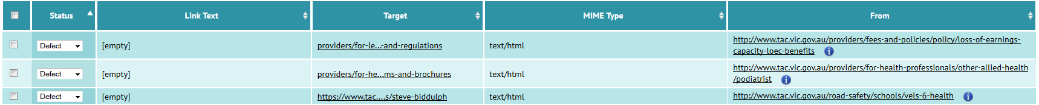
Any page in this report fails COD_A29
JavaScript (ONCLICK) links have been used
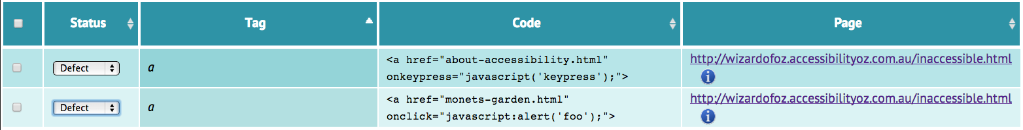
Any page in this report fails COD_A30
JavaScript links (ONKEYPRESS) have been used
Any page in this report fails COD_A31
A timed redirect has been used
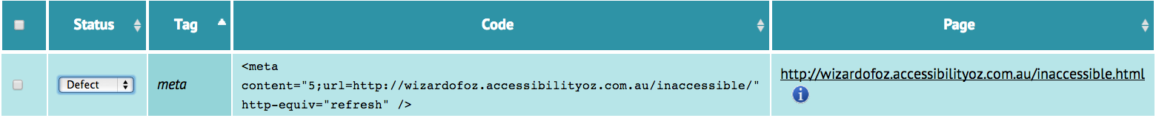
Any pages in this report must pass COD_A32
The BLINK element has been used
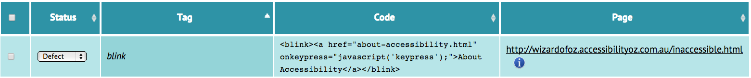
Any page in this report fails COD_A33
The MARQUEE element has been used
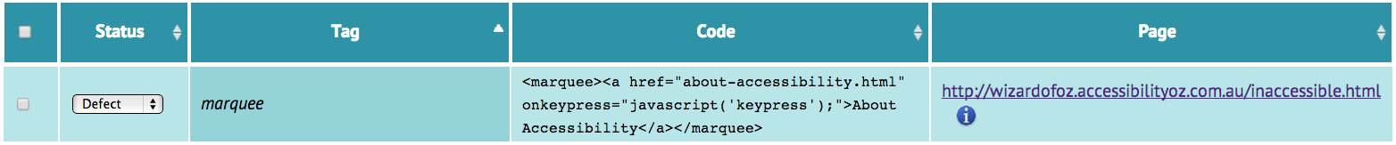
Any page in this report fails COD_A34
Some links are broken

Any page in this report fails COD_AA3

Manual checking (with the tool)
Emoticons, ASCII art or leetspeak does not have an accessible alternative
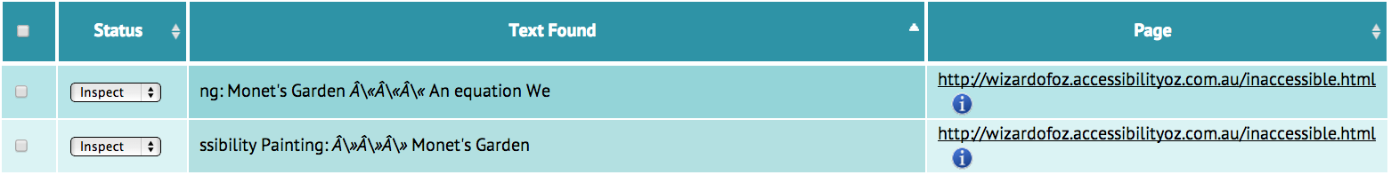
Any page in this report must pass COD_A1
EMBED does not have a text alternative
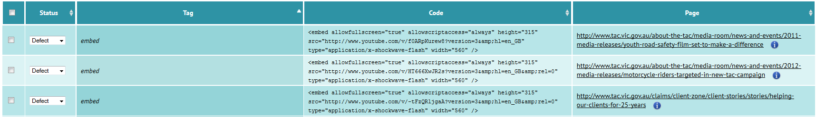
Any page in this report must pass COD_A2
IFRAME does not have an accessible alternative
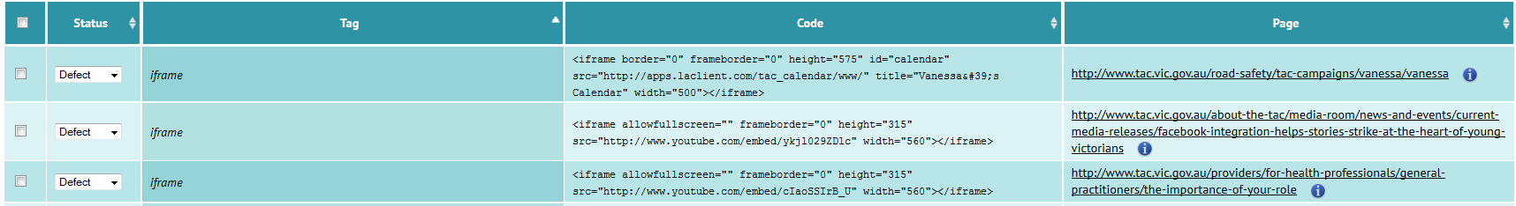
Any page in this report must pass COD_A3
Images of equations have been used instead of MathML
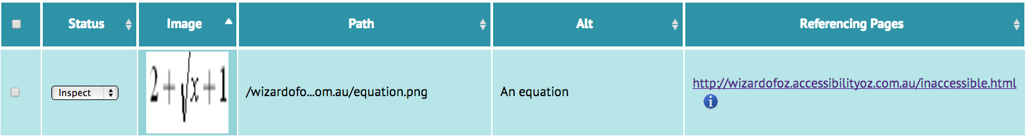
Any image in this report must pass COD_A4
Quotes have not been marked up with the Q element
Any quoted text in this report must pass COD_A5
Quotes have not been marked up with the BLOCKQUOTE element
Any quoted text in this report must pass COD_A6
FIELDSET has been incorrectly used
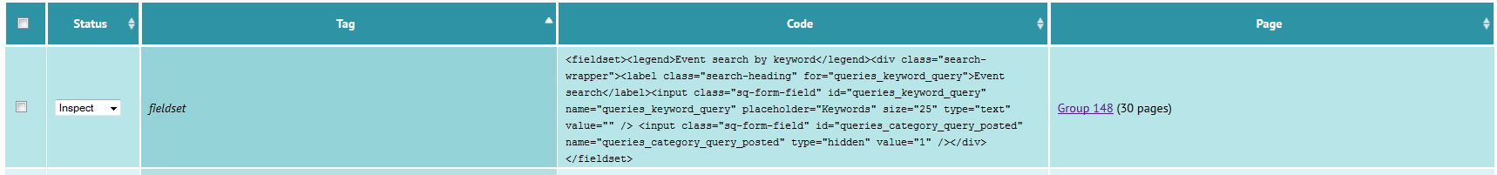
Any page in this report must pass COD_A17
LABEL has been used incorrectly
Any page in this report must pass COD_A18
BLOCKQUOTE has been used incorrectly to indent text
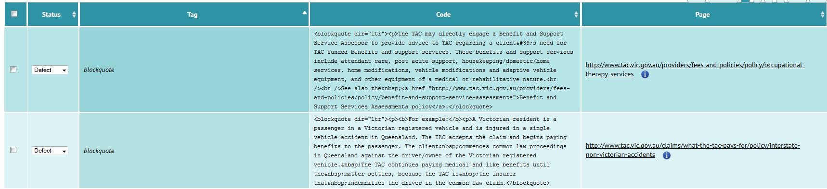
Any text in this report must pass COD_A19
Asterisks and/or superscripts have been used instead of links
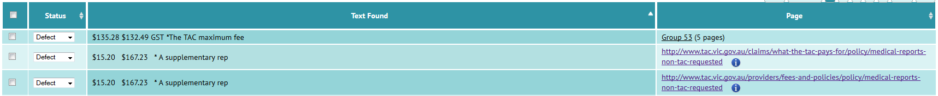
Any text in this report must pass COD_A28
Animated GIF does not stop within 5 seconds
Any content in this report must pass COD_A37
Images of text have been used instead of text
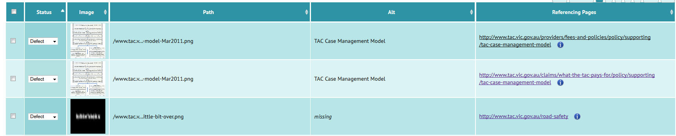
Any text in this report must pass COD_AA1

Checklists

Automated checking
Ref | Requirement | Yes | No
COD_A8 | Do all pages specify a DOCTYPE?
COD_A10 | Deprecated features (elements and/or attributes) have not been used?
COD_A11 | TABINDEX has not been used?
COD_A12 | ACCESSKEY has not been used?
COD_A13 | LONGDESC has not been used?
COD_A14 | ONKEYPRESS has not been used?
COD_A15 | The APPLET element has not been used to embed objects?
COD_A16i | Is the HTML valid (i.e. tags are closed properly)?
COD_A16ii | Is the HTML valid (i.e. XHTML tags are self-closing)?
COD_A16iii | Is the HTML valid (i.e. tags are closed in the order they are opened)?
COD_A16iv | Is the HTML valid (i.e. block level elements are not nested inside inline elements)?
COD_A16v | Is the HTML valid (i.e. compulsory tags are not omitted)?
COD_A16vi | Is the HTML valid (i.e. character entities are coded correctly)?
COD_A20 | Do elements contain mandatory attributes?
COD_A23 | Has English or Australian English been coded as the default language?
COD_A25 | Inactive text has not been coded to visibly appear like links (i.e. not underlined)?
COD_A26 | Are email links active?
COD_A27 | Are website links active?
COD_A29 | Do HREF elements contain content (i.e. are not empty)?
COD_A30 | JavaScript ONCLICK links have not been used?
COD_A31 | JavaScript ONKEYPRESS links have not been used?
COD_A32 | A timed redirect has not been used?
COD_A33 | The BLINK element has not been used?
COD_A34 | The MARQUEE element has not been used?
COD_AA3 | Are all links working (i.e. there are no broken links)?

Manual checking (with the tool)
Ref | Requirement | Yes | No
COD_A1 | Do emoticons, ASCII art or leetspeak have an accessible alternative?
COD_A2 | Does the EMBED element have a text alternative?
COD_A3 | Does the IFRAME element have an accessible alternative?
COD_A4 | Has MathML been used for equations (i.e. not images)?
COD_A5 | Have short quotations been marked up with the Q element?
COD_A6 | Have blocks or sections of text quoted from other sources been marked up with the BLOCKQUOTE element?
COD_A9 | Is the DOCTYPE correct?
COD_A17 | Has the FIELDSET element been used correctly?
COD_A18 | Has the LABEL element been used correctly?
COD_A19 | Has text been indented with style sheets (i.e. not using the BLOCKQUOTE element)?
COD_A28 | Have links been used to reference supporting information (i.e. not asterisks and/or superscripts)?
COD_A37 | Do animated GIFs stop within 5 seconds?
COD_AA1 | Images of text have not been used instead of text (except logos)?

Manual review of the site
Ref | Requirement | Yes | No
COD_A7 | Have lists have been coded properly with UL, OL and LI elements?
COD_A21 | Have variations in the presentation of text been indicated in the content of the page?
COD_A22 | Is all moving or scrolling content keyboard accessible?
COD_A24 | Is the LANG attribute correct on foreign language pages?
COD_A35 | The general or red flash threshold has not been violated?
COD_A36 | Can all moving or scrolling content be stopped?
COD_A38 | Do all session time outs have a warning?
COD_AA2 | Is the font type consistent?
COD_AA4 | Can the text be resized to 200% without loss of content or functionality?

Resources

OzART
OzART resources http://ozart.accessibilityoz.com.au

Further information

AccessibilityOz
Web: www.accessibilityoz.com.au
Phone: 03 9018 2281
Email: enquiries@accessibilityoz.com.au
Address: Level 2, 145 Flinders Lane, Melbourne 3000

